Experiment 3
Create and Manipulate Data Frames Using R

PART B

PART B: TO BE COMPLETED BY STUDENTS)
(Students must submit the soft copy as per following segments within two hours of the practical. The soft copy must be uploaded on the ERP or emailed to the concerned lab in charge faculties at the end of the practical in case the there is no ERP access available)
Roll No. C-60 | Name: Avdhut Parish Madhavi
Class : SE – C | Batch : C-2
Date of Experiment: | Date of Submission:
Grade :

Observation: (Run the programs given above in R studio and paste sceenshots of along with the output)
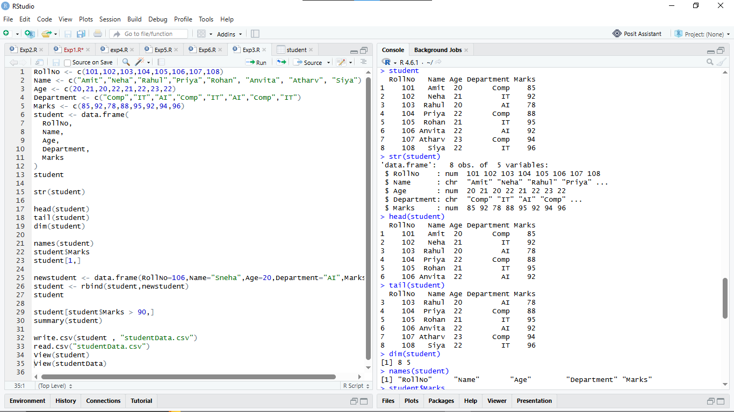

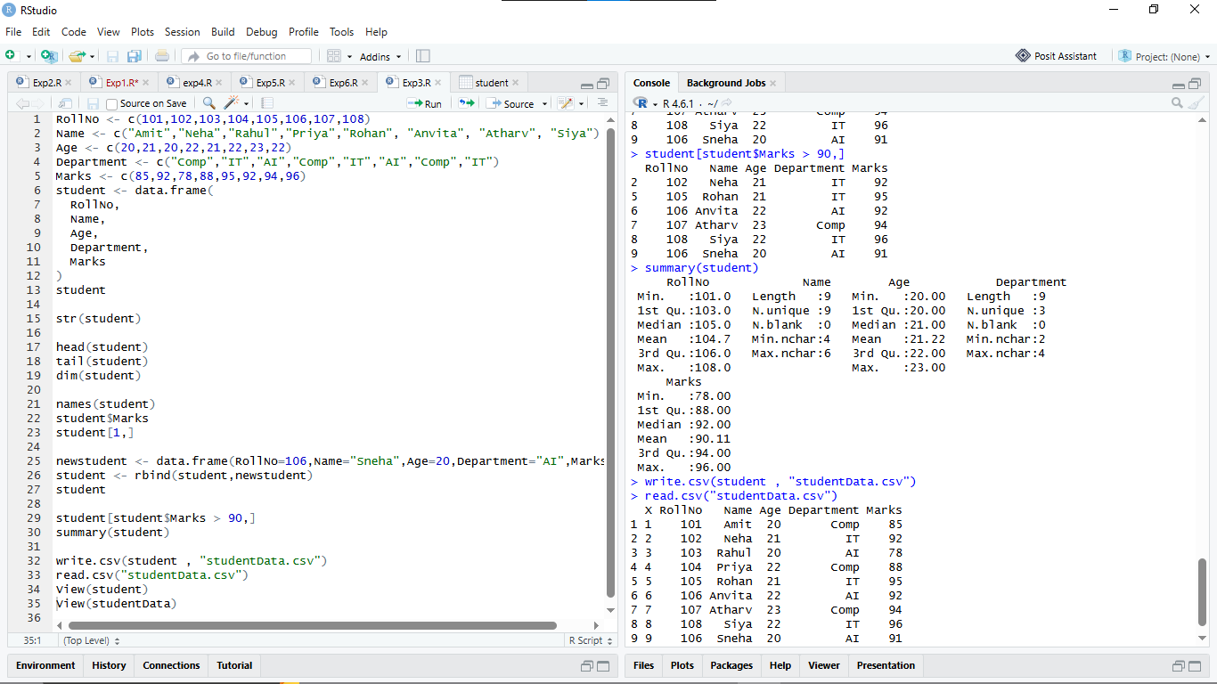

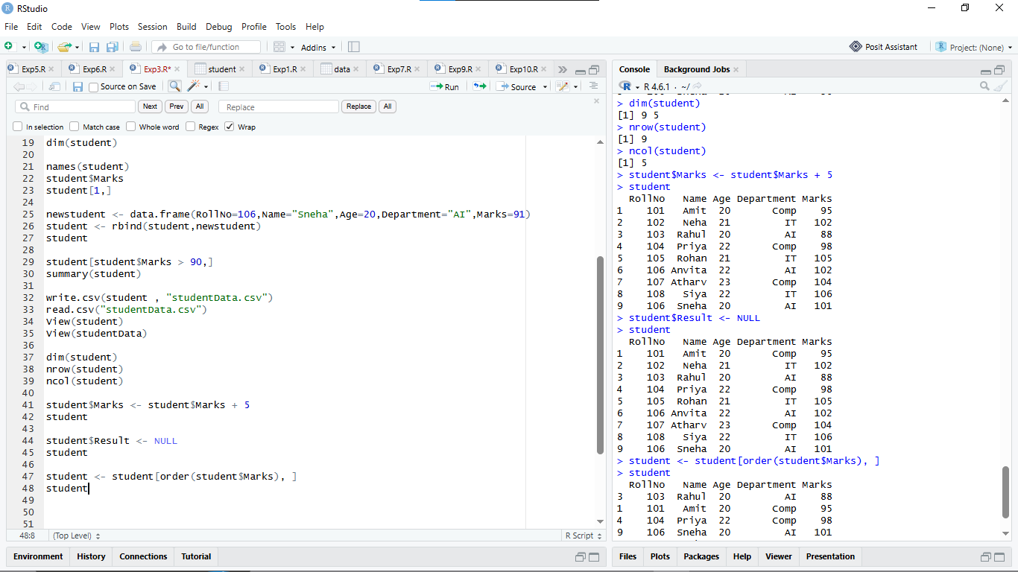

Observation Table:

Common Data Frame Functions
Function | Purpose
data.frame() | Creates a two-dimensional tabular data frame from individual vectors or variables
head() | Displays the first few records (default is the first 6 rows) of the data frame.
tail() | Displays the last few records (default is the last 6 rows) of the data frame.
str() | Displays the internal schema/structure, including total observations, variables, data types, and sample values.
summary() | Generates summary statistics (Min, Quartiles, Median, Mean, Max for numeric fields; counts for factors).
dim() | Returns the dimensions of the data frame as a vector: c(rows, columns)
nrow() | Returns the total count of rows (observations) in the data frame.
ncol() | Returns the total count of columns (variables/attributes) in the data frame
names() | Retrieves or modifies the column names (headers) of the data frame.
View() | Opens a spreadsheet-style, interactive tabular viewer for the dataset in RStudio.
subset() | Extracts specific rows and columns that satisfy defined logical conditions
order() | Returns the row permutation indices to sort the data frame in ascending or descending order.
write.csv() | Exports and saves the data frame to a comma-separated values (CSV) file on the disk.

Result:

A student dataset was created as a data frame in R, its schema and properties were inspected, and various manipulation operations—such as adding/deleting rows and columns, modifying values, filtering based on logical conditions, and sorting—were implemented. Finally, the manipulated data was exported to StudentData.csv.

Questions of Curiosity:
- What is a data frame in R?
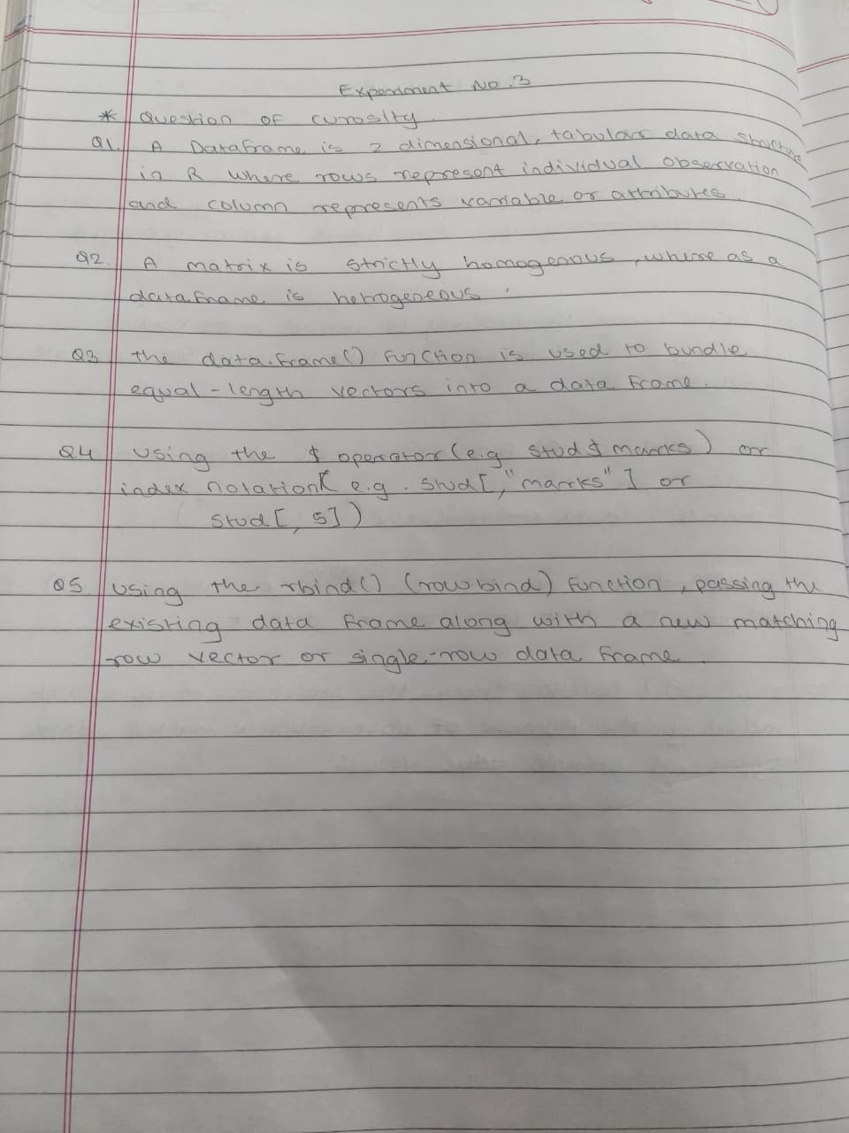
- How is a data frame different from a matrix?
- Which function is used to create a data frame?
- How do you access a specific column in a data frame?
- How can you add a new row to a data frame?

Viva Voce Questions
1. What is a data frame in R?
A data frame is a two-dimensional data structure in R that stores data in rows and columns. Different columns can contain different data types, such as numeric, character, and logical values.
2. How is a data frame different from a matrix?
A data frame can contain different data types in different columns, whereas a matrix generally contains elements of the same data type.
3. Which function is used to create a data frame?

The data.frame() function is used to create a data frame in R.
Example:
df <- data.frame(Name = c("Amit", "Riya"), Marks = c(85, 90))
4. How do you access a specific column in a data frame?
A specific column can be accessed using the $ operator or double square brackets [[ ]].
Example:
df$Name
df[["Marks"]]
5. How can you add a new row to a data frame?
The rbind() function is used to add a new row to a data frame.
Example:
df <- rbind(df, data.frame(Name = "Raj", Marks = 88))
6. How can you delete a column?
A column can be deleted by assigning NULL to it using the $ operator.
Example:
df$Marks <- NULL
7. What is the purpose of the summary() function?
The summary() function provides a statistical summary of the data, such as minimum, maximum, mean, median, and quartiles for numeric columns.
Example:
summary(df)
8. Explain the difference between head() and tail().
- head() displays the first six rows of a data frame by default.
- tail() displays the last six rows of a data frame by default.
Example:
head(df)
tail(df)
9. How do you filter records in a data frame?
Records can be filtered using a condition inside square brackets or the subset() function.
Example:
df[df$Marks > 80, ]
This displays records of students whose marks are greater than 80.
10. Which function is used to export a data frame to a CSV file?
The write.csv() function is used to export a data frame to a CSV file.
Example:
write.csv(df, "data.csv", row.names = FALSE)
11. What is the purpose of View()?
The View() function displays a data frame in a spreadsheet-like tabular format in RStudio, making it easier to inspect the data.
Example:
View(df)
12. Explain the use of str() and dim() functions.
- str() displays the structure of an object, including column names, data types, and sample values.
- dim() returns the dimensions of a data frame as the number of rows and columns.
Example:
str(df)
dim(df)
13. What is the difference between rbind() and cbind()?
- rbind() combines data frames by adding rows.
- cbind() combines data frames or vectors by adding columns.
14. How do you sort a data frame in ascending order?
The order() function is used to sort a data frame in ascending order based on a specific column.
Example:
df <- df[order(df$Marks), ]
This sorts the data frame by marks in ascending order.
- Mention any five real-world applications of data frames.
- Student marks and academic records management.
- Sales and business data analysis.
- Patient and hospital record management.
- Financial data and stock market analysis.
- Weather data analysis and forecasting.

